

**Placement Empowerment Program**

***Cloud Computing and DevOps Centre***

# POC 2: Automate File Copying with a Script

Create a script to copy files from one folder to another automatically.

Name: Manashaa U Department:CSE



# Introduction

File copying is a basic computer operation where an exact duplicate of an existing file is created, essentially making a new file with the same content as the original, allowing you to have multiple versions of the same data in different locations on your system

# Step-by-Step Overview

## Step 1

Create two folders , name them “source” and “destination”.



## Step 2

Open notepad and type the following code

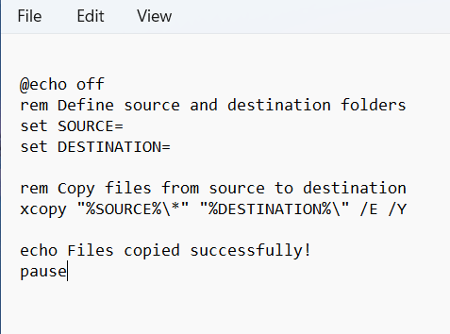

## Step 3 :

Save the file with “.bat” extension

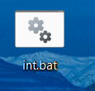

## Step 4

Open task manager and click on basic tasks , then give the file name and description, set time to check and other details then browse the file with “.bat” extension and click on “next” and create the task



## Step 5

You can now automatically copy the files. add a file in source folder then click on the “.bat” extension. The files will be copied automatically to the destination folder



# Outcome

This is very helpful for large set of data. This will reduce human errors and will also act as data backup. We can use this to transfer files from applications and servers. Thus, this comes handful when we want seamless transfer of data